Kristopher Lowell

EECE-3050-201

Fall 2018

Assignment 1 Results

237.75

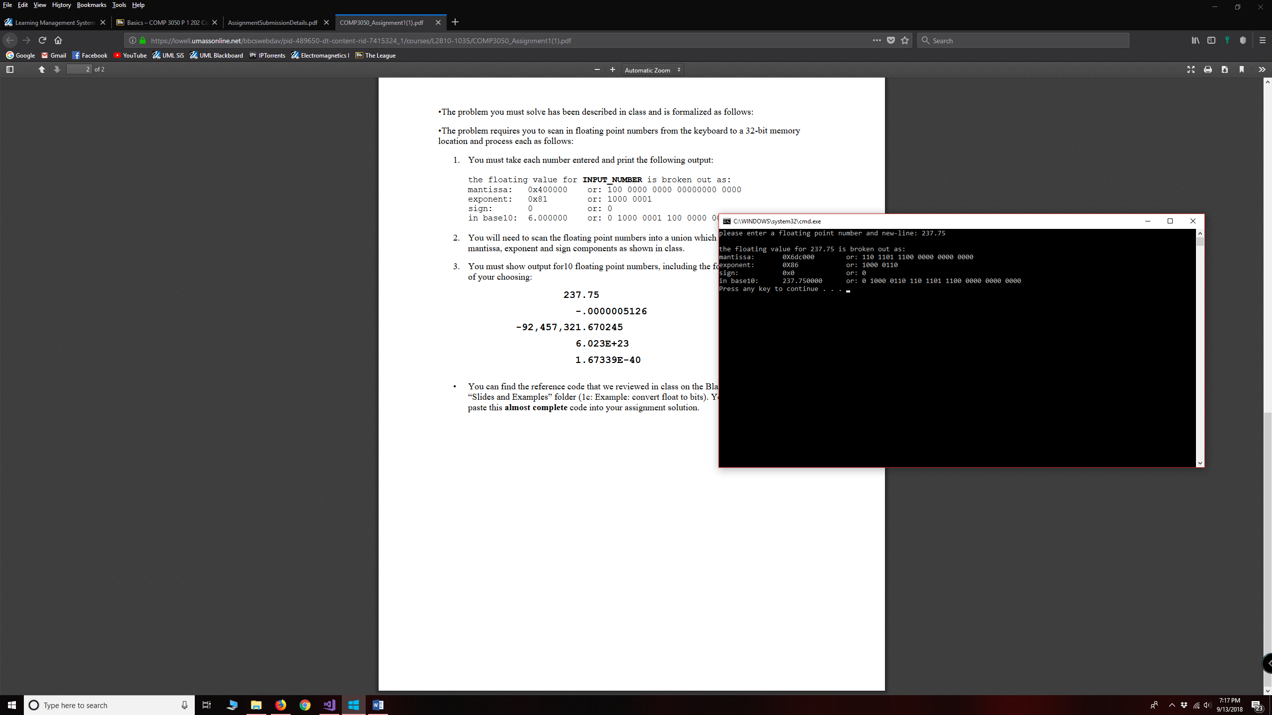

-.0000005126

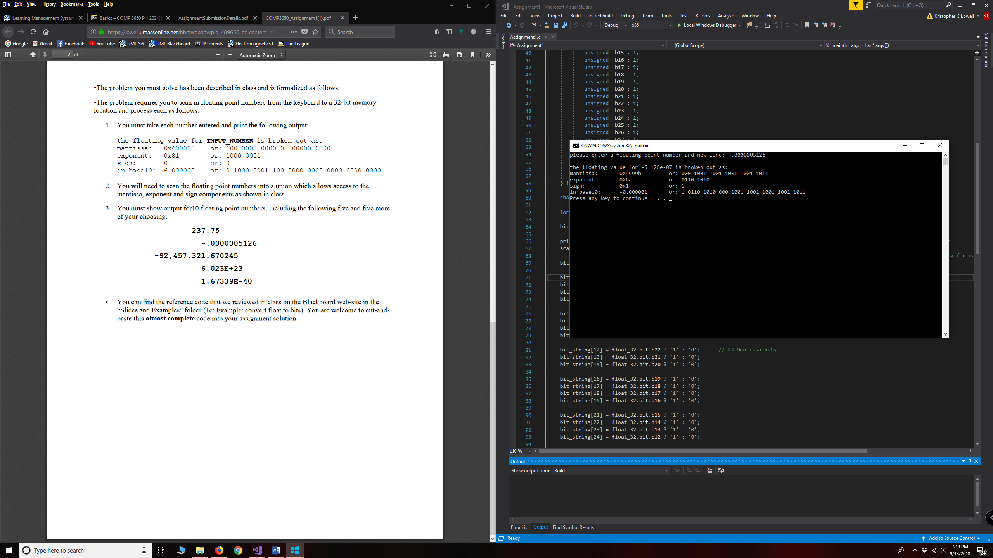

-92,457,321.670245

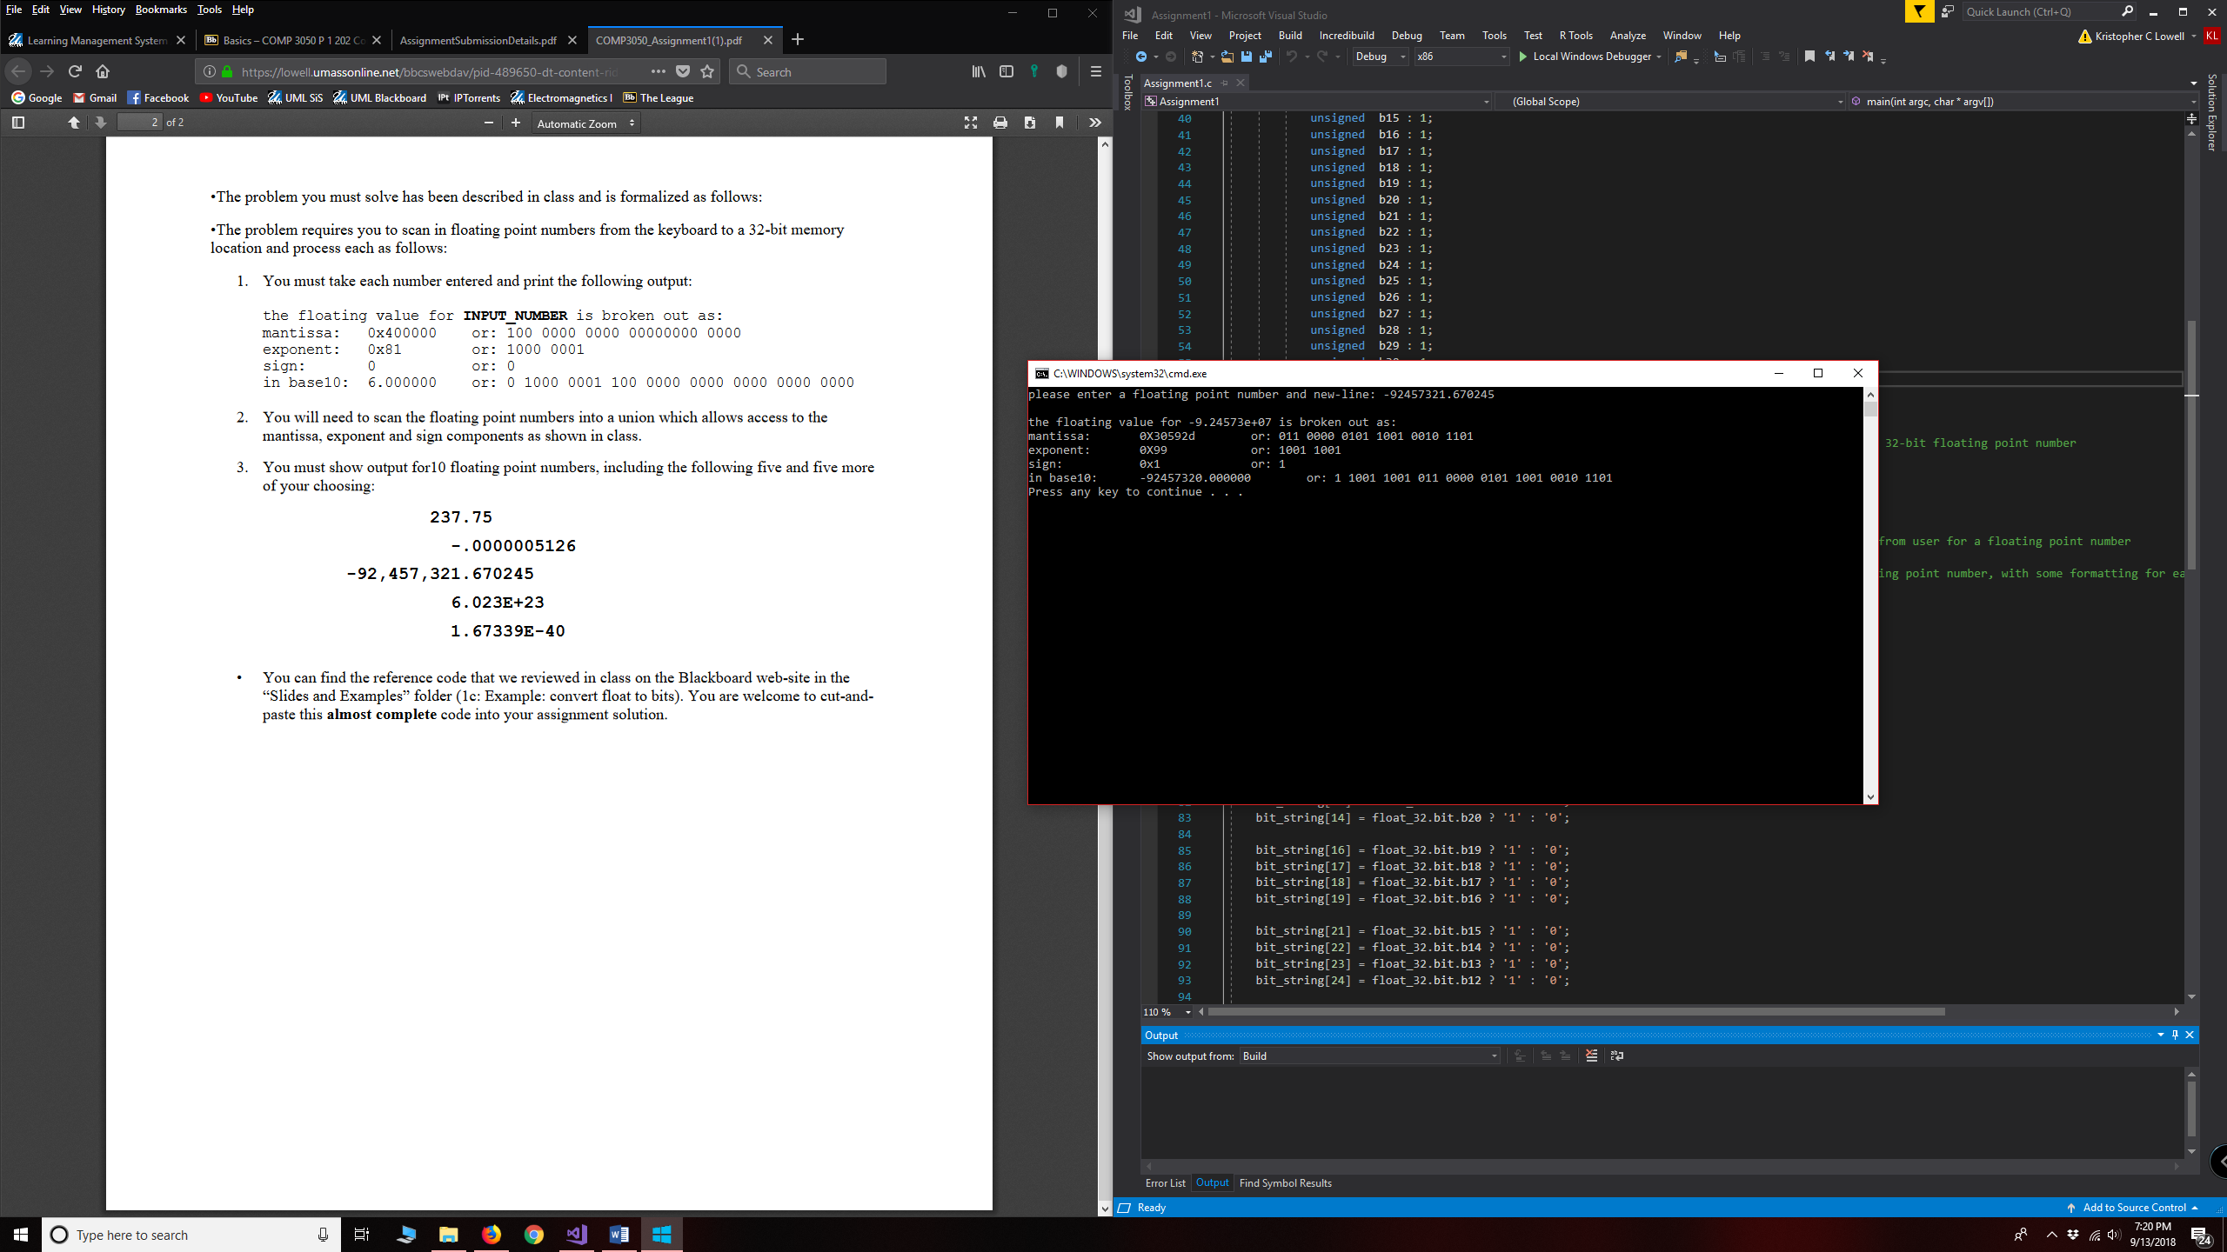

6.023E23

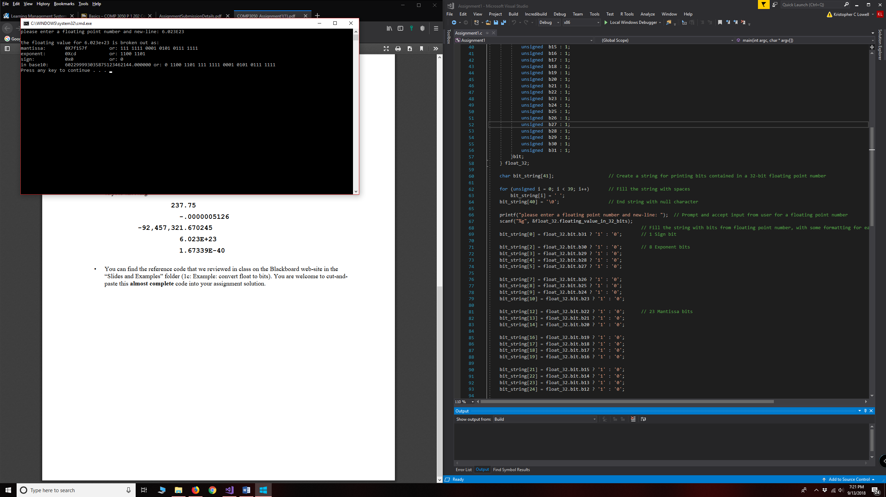

1.67339E-40

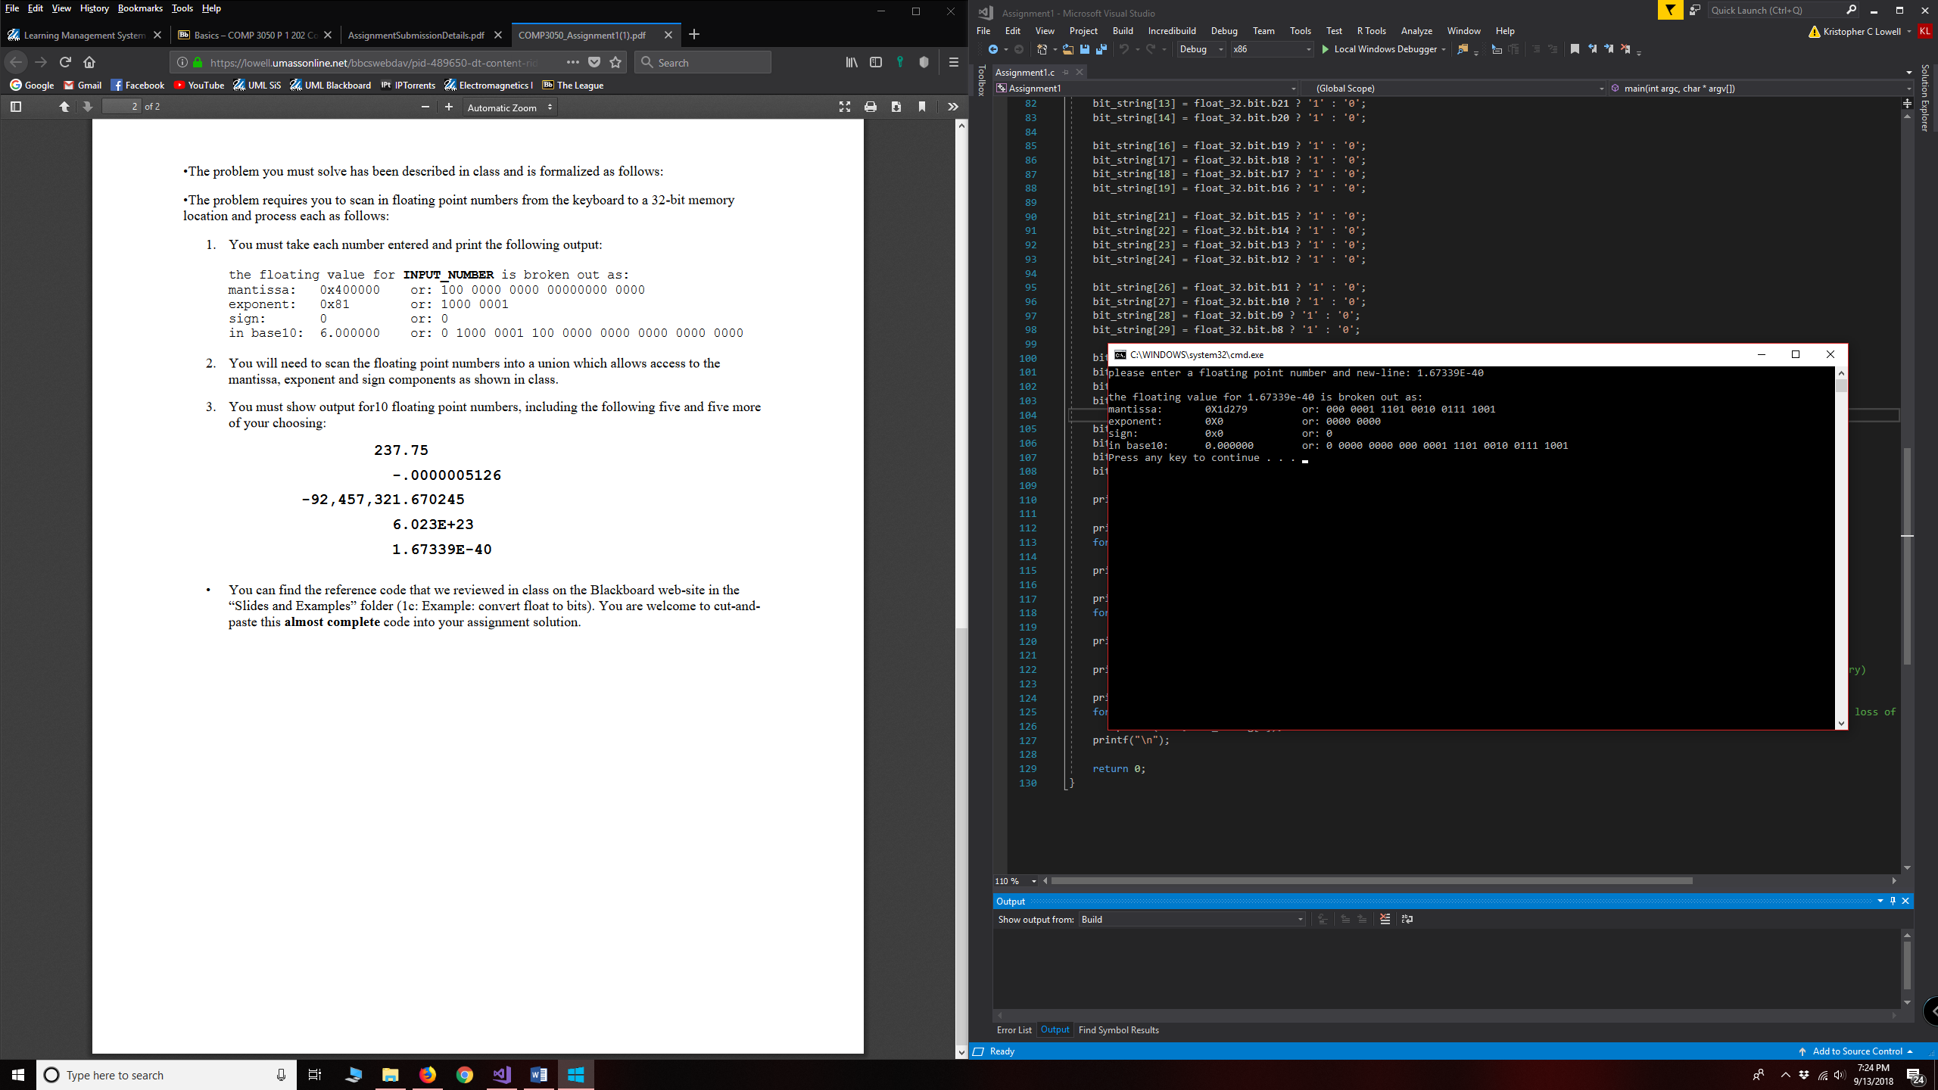

3.625 (3 5/8, an easy number to do by hand)

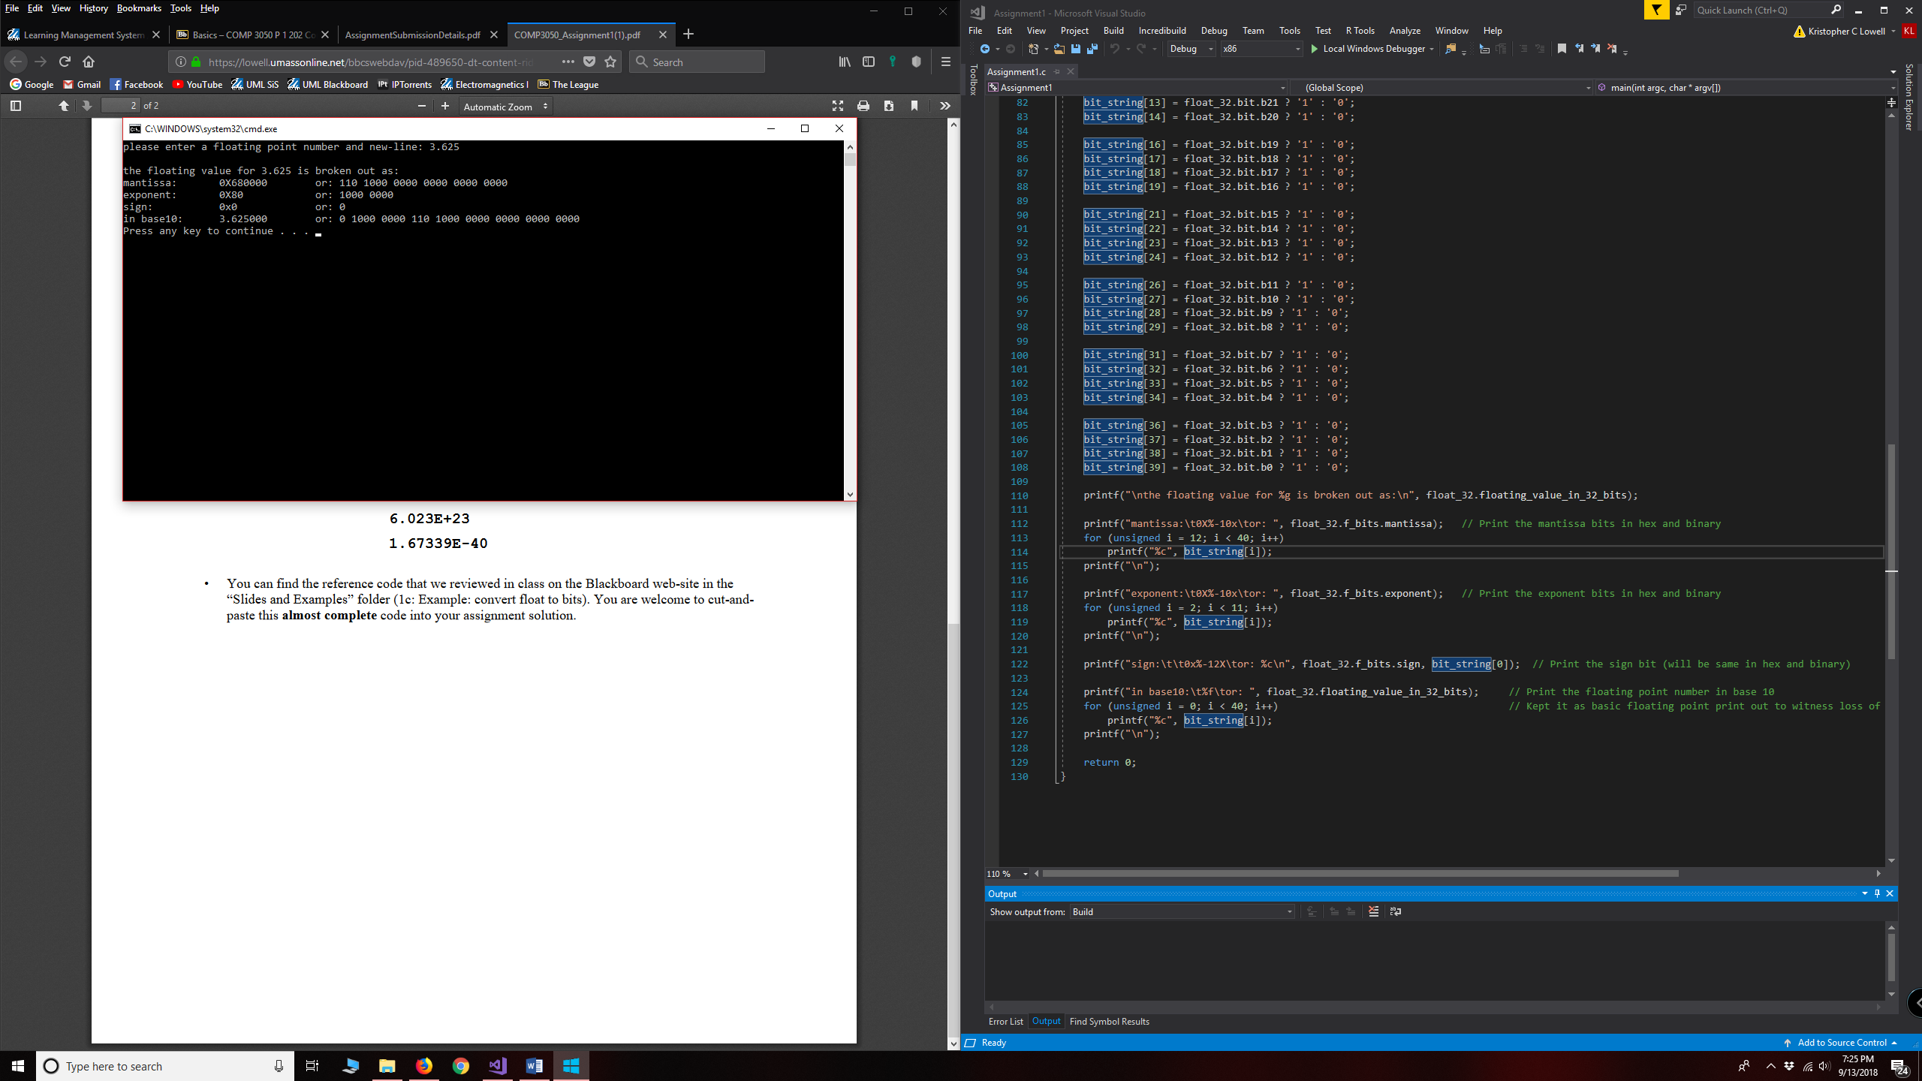

-6E40 (purposely large number for testing negative infinity)

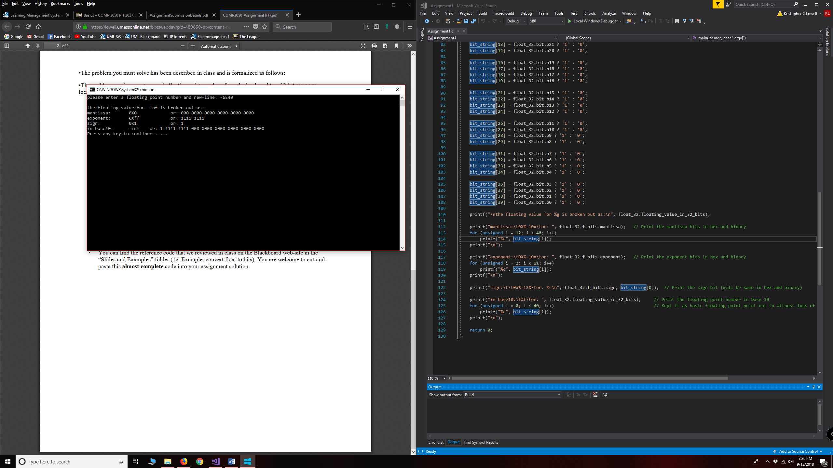

0

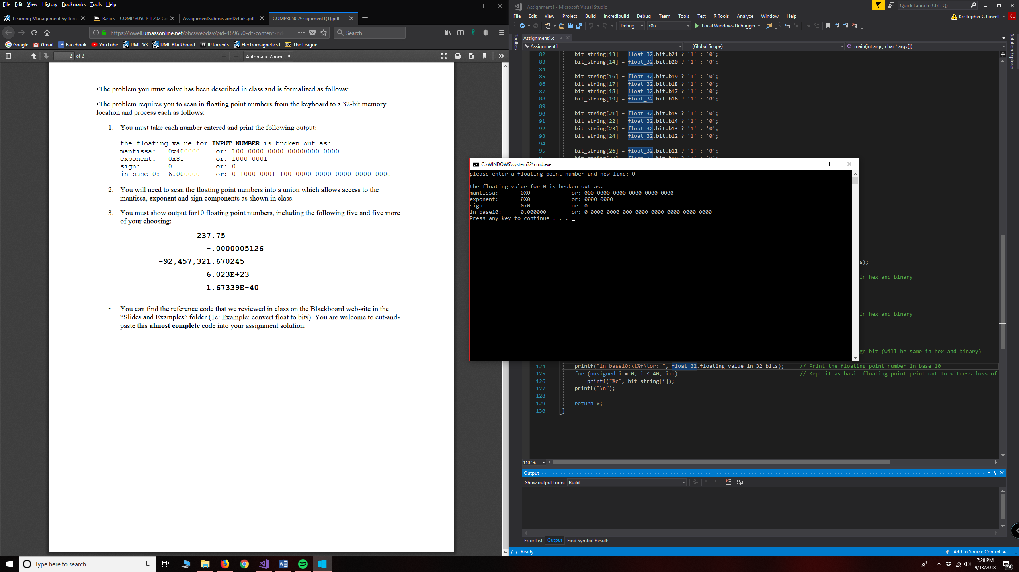

3.14159265358979 (pi)

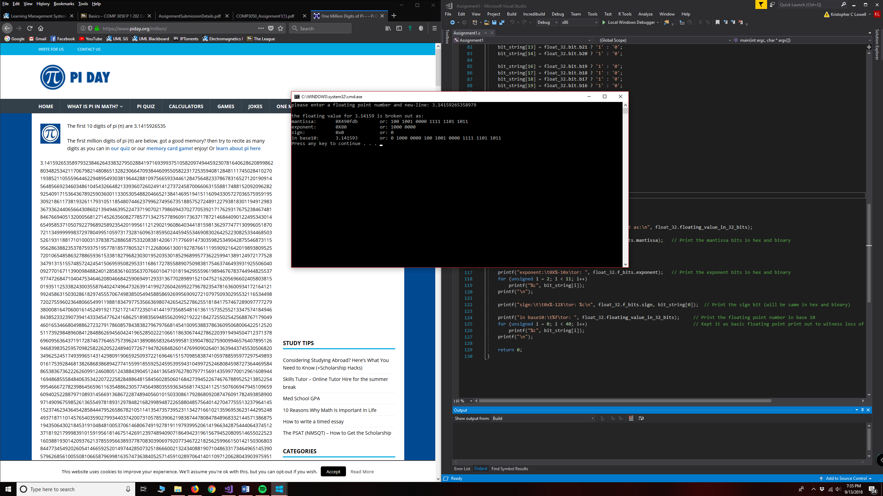

-299792458.0 (negative speed of light)

